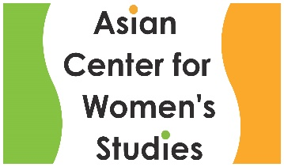
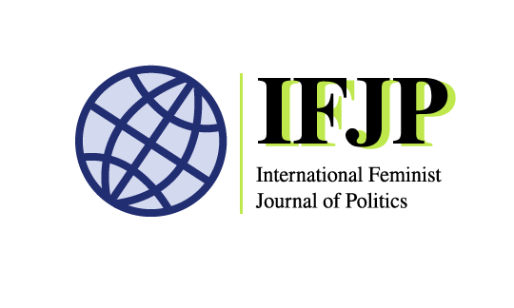
International Feminist Journal of Politics-Asian Center for Women’s Studies
Ewha Womans University
Hybrid Conference
South Korea, July 21-23, 2022

Remapping the feminist global: A multi-vocal, multi-located conversation

We invite participants to this multi-location hybrid conference, ‘Remapping the feminist global’ co-convened by International Feminist Journal of Politics and Asian Center for Women’s Studies, Ewha Womans University.

Feminism(s)– like other academic knowledge and global movements – bear the effects of historic and new permutations of Eurocentrism, colonialism and imperialism that continue to shape not only feminism but the global world we inhabit and seek to change. Convened in South Korea, this 2022 conference turns to Asia as a geographic location and imaginary that offers an important anchoring for global feminist conversations to move beyond the current hegemonic hold of the West and the (imperial) nation-state system that emerged wherein the global governance structure has pre-determined how feminism becomes a salient political and academic discourse. Urgently needed are collective reflections on emerging hierarchies not only between West and non-West but as the focus of this call for conversation, the hierarchies and relations in and between ‘the non-West’. Feminist scholars, editors, policymakers, practitioners, activists and teachers, more than ever, need to come together to exchange ideas and co-create transnational and/or global feminist futures by mending broken linkages. This is an age-old conundrum that has riddled feminist inroads into institutions and public spaces; we seek a more satisfactory redress in the wake of greater separate and parallel developments in feminist research in siloes, global anti-feminist backlash and polarization of politics.

The set of questions animating this conference is: How do feminists across regions and locations speak and share ideas when the work cannot wait for academic feminists, when the worlds we live in and work to change do not wait and cannot wait for academic conventions to catch up? These questions are not discrete or exclusive. We encourage and expect work where multiple inquiries/conditions/ identities/ experiences intersect and/or collide.
We believe that in a world where feminists working in universities as organic intellectuals and teachers for change not only requires foundational interrogation but also demands radical methodological moves to keep true. In this spirit, we invite critical and creative discussions that expand and better locate the ‘academic research’, ‘university’ and ‘scholarship’ with artists, poets, activists, and policy practitioners across regions and locations. We believe engendering new, surprising conversations and encounters that would otherwise not happen should be the main way we think about inter-institutional, and interdisciplinary collaboration across the activist-academia divide and locations.

Format
The two-day in-person proceedings will be held in Seoul hosted by the Asian Center for Women’s Studies, Ewha Womans University. They will be livestreamed, allow online participation, and connected with three additional hubs in Oceania, South East Asia and South Asia (hubs will be announced early 2022). The third day of the conference will be fully virtual, hosted by the hubs each convening a plenary event as well as functioning as a physical gathering place for that day for those who can travel to these sites better.

Themes
We are inviting individual and co-authored papers, panels, roundtables, book launch proposals, and other creative proposals under the theme, Remapping the feminist global: A multi-vocal, multi-located conversation convened by co-hosts, ACWS, which houses Asian Journal of Women’s Studies, and IFJP. All participants will be invited to submit their papers to the journals for their respective special issues after the conference.

This gathering recognizes Asia is plural, requiring inter-Asian exchanges, and further, that the global world requires more careful remapping and engagement via and from Asia. With inter-Asia/plural Asias at the center, the conference also seeks to explore the global through interregional south-south connections such as Afro-Asia and Pacific-Indigenous-Asia. The gathering also seeks to remap global feminism through rethinking disciplinary and academic categories of knowledge production that marginalize feminist visions, bodies, connections and modes of politics and knowing.

Centering Asia as a way of disrupting hegemonic discourses requires a reckoning with race, racialization and the dynamics of gender discourses that are shaped by western and colonial influences. We invite diverse scholars and knowledge producers to convene under this theme to engage in multi-levelled and nuanced conversations about how issues of race, gender and racialization are conceptualized and entwined, how they manifest, what meanings they carry, especially when using terminologies developed and spread from imperial spaces. We hope to stimulate scholarly debates that think through implications of these alternate discourses in light of the urgent need to dissect ramifications of racial, ethnic and gendered discriminations particularly when examined from Asian and postcolonial settings.

We invite diverse and innovative submissions from feminists with strong critical, methodological, and theoretical strengths in the themes below. The categories are not meant to be mutually exclusive or exhaustive, and we welcome especially what may be amiss in them. We also especially encourage submissions offering new explorations of Asian feminisms, energizing feminist debates about processes of racialization that can help us to develop transformative visions to enact change, and delve into new directions.

Postcolonial and non-western feminist theories and practices
- methods and theories on remapping the feminist global through Asia and/or other locations
- methods for theorizing the intimate, aesthetics and/or the non-
- military colonialism and neocolonialism
- empires and imperialism
- south-south relations and internationalisms

Feminist politics and policy
- feminist perspectives on humanitarianism and human rights
- discourses and practices to tackle gendered/sexualized violence
- hate crime, affect, and activisms
- activism and in-between spaces as sites of democratization
- sexuality, liberation and body politics

Race, racialization and gender
- racialization and racial hierarchy in Asia
- intersectional discrimination, anti-multiculturalism and activism
- gendered and racialized social policies and institutions
- gendered and racialized experiences of the Covid19 pandemic
- queer perspectives on race and racial issues
- migration and displacement

Submission Date: 28 February 2022

Submission Type: Individual and co-authored papers, panels, roundtables, book launch proposals, and other creative proposals

Submission Method: Submit your 250-word abstracts by filling out the form here.
Please note: For panel or other multi-person submissions, you will need information of all your panelists/contributors including, individual contribution/paper abstracts, email addresses, location/institution information, and mode of participation

Notification Date: 19 March 2022

Questions? Contact a member of the Organizing Committee:
shine choi, Te Kunenga ki Pūrehuroa Massey University, Aotearoa New Zealand (s.choi1@massey.ac.nz)
Bina D’Costa, Australia National University, Canberra, Australia (bina.dcosta@anu.edu.au)
Ji young Jung, Ewha Womans University, Seoul, South Korea (acwsewha@ewha.ac.kr)
Swati Parashar, Gothenburg University, Göteborg, Sweden (swati.parashar@gu.se)

