File Synchronization Scheme using Similarity Deduplication
0¹, 00²
^{1,2}Dept. of,
@
Abstract. The file synchronization service is one of the essential service in cloud storage system. The current file synchronization scheme has drawback handling multi-client synchronization. In this paper, we propose a novel file synchronization scheme that uses the similarity-based de-duplication scheme, which helps to use of storage system efficiently. The file synchronization scheme reduces network traffic efficiency. The key idea of this paper is to provide a file synchronization scheme between the server and the client using file similarity information and reducing data copying overhead. Experimental results show that the proposed scheme can reduce network traffic and increase overall performance of the cloud storage system.

Keywords. File Synchronization, Cloud, Deduplication, File Similarity
1. Introduction
As the cloud system is widely used in the computing service, the cloud storage services including N-drive, Daum cloud, Dropbox, Skydrive and Google drive, are now popular and gain attention to enabling technology for future internet service. Google drive service is one of the most popular cloud storage devices among the customers combines with several purposes. In particular, file synchronization schemes can be maintained the same number of files to clients, but cloud system increases the reliability of the file rather than other storage systems, and used for a time period in modified files. Google drive provides a really effective way to search the files in storage drive of users and the files by using an image scanning function and self-scanning technology for optical character recognition of the operating system. Cloud system has also provided the facility to share large numbers of files among the large number of users. Nevertheless, Google cloud storage technology is having a problem to manage the large quantity of data. Current technology does not provide the way to utilize the bulk of data redundancy by utilizing the cloud storage box except Dropbox.
In a cloud storage system, file synchronization is very important to support multiple nodes. As the size of storage are continuously growing, it leads to difficulties and time-consuming task to synchronize lots of files. To improve the synchronization performance with rapid and low bandwidth, there are lots of challenges for improving synchronization performance using data deduplication. In this paper, we exploit the file similarity scheme for file synchronization in the cloud storage system. The file similarity evaluation method is widely used in malicious file detection. Malicious files are generated by modifying original executable file, so the file similarity search is used to identify file similarity or find malicious code from the executable programs within the system. Usually, the malicious file is very similar with original file because file patch is appended in the middle of original file.
In this paper, we adapts file similarity scheme to find a candidate file that has high probability of data duplication. By selecting high similarity file, we can apply the file synchronization algorithm between a client and a server. The key idea is to reduce the metadata size by applying piecewise hash algorithm for each file. Furthermore, we reduced hash values by adapting representative hash during variable-length chunking process. We compared the performance of this technique, variable-length chunking and fixed-length chunking. We showed that we can considerably improve the execution time to search file similarity with a good accuracy and reduce the metadata size.
The rest of this paper is organized as follows. In Section 2, we describe related works about deduplication system. In Section 3, we explain the design principle of proposed system and implementation details for data deduplication using two-level scheme. In Section 4, we show performance evaluation result of the proposed system and we conclude and discuss future research plan.
2. Related Works
To reduce data storage system, there are several approaches. The well-known scheme is data deduplication approach where data file is compared by their fingerprint value. If the fingerprint is same between files, we assume that the files are same. This approach can be applied to block-level data deduplication. By dividing each file as a fixed or variable blocks, we can get fingerprint of each blocks. If the fingerprint value is already exist on the server, we don’t need to send the block to the server because the block is already on the server. The data deduplication approaches are categorized as three; source-based, inline and post processing approach. The source-based approach performs data deduplication in the client side and the client sends only non-duplicated files or blocks to deduplication server. The client divides a file into several blocks and calculates hash key for each block. In the chunking process, the block can be divided into fixed size chunk or variable size chunk depending on chunking approach. The list of hash keys is delivered to the server and the server checks duplicated blocks by comparing the hash key with hash keys in the server. The server makes a non-duplicated block list and sends it to the client. Finally, the client sends the non-duplicated data blocks to the server. Inline approach performs data deduplication on the server side. A client sends file stream to the server then the server process deduplication work on the fly by chunking the file stream into blocks. In inline approach, the server has enough CPU resource and memory capacity for processing data deduplication. Finally, in post processing, the system first stores file stream on a temporary storage and performs data deduplication work later. Accordingly, the server needs additional storage device and all the computation can be delayed until there is available resource. Inline and post processing approach usually consume the system resource of a server while minimizing the client resource because all the deduplication work is processed on the server side.
Data deduplication system handles similar files with various chunking approaches [1,2,3]. The well-known chunking approaches are fixed-length chunking and variable-length chunking (content-defined chunking). Deduplication approaches can save computing resources through detecting the file similarity and eliminating the duplicated region of a file. In file similarity searching system module[4,5], the performance depends on hash comparison speed, therefore effective hash comparison is very critical. One of the well-known data deduplication scheme is Venti that is a network storage system using fixed-length chunking approach. The key idea of Venti is to divide a file into fixed blocks and check duplicated blocks using 160-bit SHA1 hash key. Venti can reduce storage capacity by eliminating multiple duplicated blocks that have the identical data, so duplicate data is easily identified and the data block is stored only once. In variable-length chunking, each block size is partitioned by anchor value that divides a file into variable size chunk. One of the well-known variable-length chunking is a LBFS that exploits similarities between files or versions of the same file. LBFS avoids sending data over the network when the same data found in the server file system. LBFS achieves up to two orders of magnitude reduction in network band width. In our previous research result, data deduplication system uses file modification pattern. This approach can detect how file is modified and what types of deduplication is best for data deduplication. Therefore, the optimal data deduplication policy can be applied to a file.
Well-known block hashing schemes are used for file similarity search[1,2]. Fixed-length chunking[3] lets files be divided into a number of fixed-sized blocks, and then applies hash functions to extract a hash key of the blocks. Fixed-length chunking is very simple, light-weight scheme and is easier to implement than variable-length chunking[4]. But the drawback of fixed-length chunking is the data shifting problem. For instance, if some of data is inserted or deleted at the boundary of block, the result of hash value can be almost changed differently. So the similarity accuracy usually shows bad performance. In content-defined chunking or variable-length chunking, each block is partitioned using special hash values called anchor. This scheme can prevent the data shifting problem of fixed-length chunking which is a fast duplication approach. So variable-length chunking is more flexible than fixed-length chunking but requires more computation time to achieve good similarity accuracy. Piecewise hash[5] also widely used to detect similarity between files. This mechanism concatenates part of hash values and generates string values for each file. By adapting Locality-sensitive hashing (LSH) algorithm[6], it can find similar hash string. LSH is a method of performing probabilistic dimension reduction of high-dimensional data to hash the input items so that similar items are mapped to the same buckets with high probability.
3. System Design and Implementation
Figure 1 explains how similarity algorithm using representative hash works. First, a file stream is divided into variable chunks. The system calculates a hash key for fixed size blocks for each chunk. Conceptually, the sorting module lines up hash keys and makes a hash key list with ascending order or descending order. From the sorting list, we only take a few hash keys for representative hash values.
Rabin hash function is used for computing a hash key for a block. The Rabin hash starts at each byte in the first byte of a file and over the block size of bytes to its right. If the Rabin computation at the first byte is completed then we have to compute the Rabin hash at the second byte incrementally from the first hash value. Now that the hash value at the second byte is available then we use it to incrementally compute the hash value at the third, and continue this process. In this work, we have to sort the Rabin hash value and choose small number of maximum values as a representative hash.

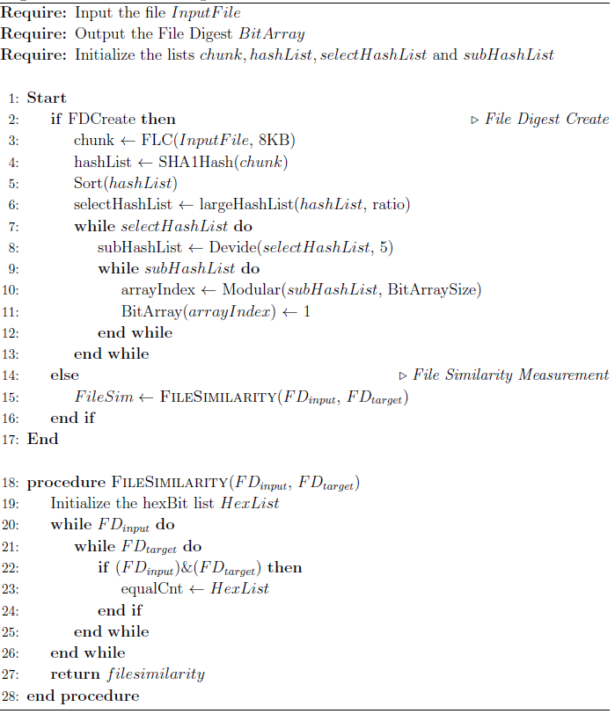
Figure 1. Representative hash algorithm
In this paper, we propose a novel file similarity scheme that uses fixed length chunking and piecewise hash approach. To make file similarity hash string, files are divided into multiple chunks with fixed size, and by applying fingerprint function, we can generate hash string of each chunk. By searching high similarity files with hash string, we can find similar files rapidly. This technique is much faster than traditional data deduplication systems which chunk all the file and compare hash data of a client to the server one. The proposed scheme first compare hash string and find most similar files in the server. And then, it applies data deduplication algorithm. The proposed scheme reduces hash comparison time by using hash string, but the well-known file similarity evaluation schemes adapts representative hash approach and it takes very long time to evaluate the level of file similarity.

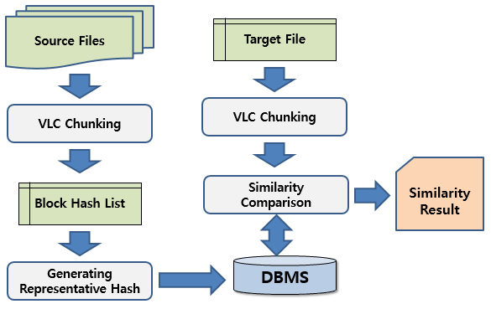
Figure 2. System architecture of the proposed system

The key idea of our work is three-folds: First, we adapt file similarity concept. We can measure file similarity by comparing hash keys for each file blocks using representative hash scheme. The higher file similarity between two files means that less modified data blocks exist between two files. Second, we adapt variable-length chunking and extract representative hash list. In this approach, a file is divided into several variable-sized blocks with anchor. It gives more flexibility for inserting and deleting some data on a file. Finally, we adapt concatenation of hash keys to reduce metadata size and sorting scheme to improve searching time.
Figure 2 shows the overall architecture of the proposed system. It has several procedures to get the similarity result between a target file and a source file. We distinguish two phase, generation phase and search phase. The first is the generation phase that is devoted to generating and maintaining a collection of source files. DBMS with metadata of source files should be generated in order to compare a target file. The second is the search phase that is devoted to analyzing a target file using the material generated earlier. Figure 2 describes the procedure of generation phase. The main function is to extract file similarity metadata. Finally metadata will be stored in DBMS.
The proposed system composed of 4 steps; variable-length chunking and hashing, sort hash keys and select representative hashes, make string hash as metadata by concatenating 1byte LSB of each hash, store metadata in DBMS. In step 1, the proposed system scans source file. Each source file is divided into variable-length sized blocks between anchors. In our system, we used Rabin fingerprint for scanning anchor values. Rabin fingerprint is known for fast hash algorithm using byte shift scheme, so scanning overhead is very low compared to other approach. Once we find a variable block, we apply strong hash scheme, SHA-1 to get fingerprint of a block. In step 2, the representative hash values are computed by sorting hash values and choosing maximum hash values. In this work, we made the representative hash list for all files. We extract 100 representative hash values for each file. In step 3, we generate a hash string by concatenating 1 byte LSB of each hash. There are various schemes making hash string for a file. The proposed system only takes one byte for each representative hash value and makes a hash string. Finally, all hash string of source files are stored in DBMS with its metadata information.
In our algorithm, we finds anchor byte and seeks the current file position using standard I/O function in UNIX system, seek() function. We can get a variable-length sized blocks from file stream. And then, we can generate new hash key using SHA-1 hash function with the byte of current position. The hash key is compared with previous hash keys. If the hash key is bigger than a hash key in hash array, we replace the new hash key with minimum value in hash array. This procedure repeats to the end of file and the output of this loop is the sorted hash list. We select representative hashes from sorted hash list. In our experiment, 100 hash values are selected to search file similarity. Finally, the metadata is formed by concatenating the one byte (8bits) least-significant bits of block hash value in order to reduce the required memory space and computation time.

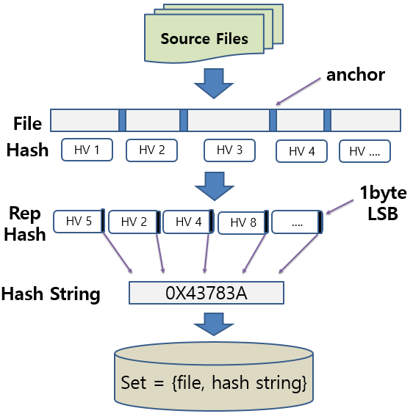
Figure 3. Generation phase for building the reference collection with metadata
4. Experiment
We experimented our scheme by comparing well-known similarity search approaches, fixed-length chunking and variable-length chunking scheme. We performed experiments on three data sets. We made the target files (size: 100MB) by patching a random data block to source file. In fixed-length chunking, chunk size is 4KB that is fixed, so total number of chunks is 25,600 for file size 100MB. Each chunk has its own hash value. Therefore total number of hash values is also 25,600. In variable-length chunking, each chunk size is nearly 4KB, not fixed but variable. If there is no anchor byte in 4KB chunk, maximum chunk size can be up to 16KB. Therefore total number of chunks and total number of selected hash values are 64,000 up to 256,000 because also each chunk has its own hash value.

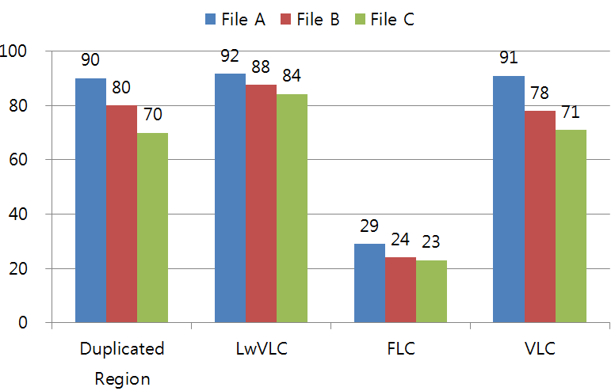
Figure 4. Experiment results of file similarity in terms of accuracy

Figure 4 presents the file similarity result in terms of accuracy. As the figure shows, the similarity accuracy of FLC shows the worst case because of the data shifting problem. VLC shows best performance because it compares all the chunk data between files. In case of LwVLC(the proposed scheme), the performance result is comparable to VLC. As noted earlier, the purpose of LwVLC is to reduce processing time of similarity search, therefore, it extremely reduces metadata size. Accordingly, the accuracy result is more or less diminished.

5. Conclusions
In this paper, we propose a novel approach for handling storage system using file similarity analysis scheme. The main idea is to reduce the overall metadata information for processing data deduplication using piecewise hash algorithm for each file. Our approach reduce hash string by adapting representative hash using variable-length chunking. We compared the performance of this technique, variable-length chunking and fixed-length chunking. We showed that we can considerably improve the execution time to search file similarity with a good accuracy and reduce the metadata size.
Reference
- Aronovich, L. and Asher, R. and Bachmat, E. and Bitner, H. and Hirsch, M. and Klein, S.T., “The design of a similarity based deduplication system”, Proceedings of SYSTOR 2009, 2009.
- Xia, W. and Jiang, H. and Feng, D. and Hua, Y., “Silo: a similarity-locality based near-exact deduplication scheme with low ram overhead and high throughput”, in ATC, pp. 1-14, 2011.
- Quinlan, S. and Dorward, S., “Venti: a new approach to archival storage”, Proceedings of the FAST 2002 Conference on File and Storage Technologies, 2002.
- Athicha M., Benjie C., and David M. “A Low-Bandwidth Network File System.” In Proceedings of the Symposium on Operating Systems Principles (SOSP'01), pp. 174–187, 2001.
- J. Kornblum, “Identifying Almost Identical Files Using Context Triggered Piecewise Hashing," Proc. 6th Ann. Digital Forensics Research Workshop Conf. (DFRWS 06), pp. S91–S97, 2006.
- A. Andoni, P. Indyk, "Near-optimal hashing algorithms for approximate nearest neighbor in high dimensions," in FOCS, IEEE Computer Society, pp. 459–468, 2006.

Author’s

00

Received B.S. degrees in information and statistics from Dongduk woman’s University, Korea in 1997. She studied in Chungang University, Seoul Korea in 2005. She is now a researcher in Department of Computer engineering, Hallym University, Korea. Her research interests include data deduplication system, multimedia system.

00

Received his B.S. and M.S. degrees from Korea University, Korea in 1997 and 1999, respectively and his Ph.D. degree in Computer Science from Korea University, Seoul Korea in 2003. He is now a professor in Department of Computer engineering, Hallym University, Korea. His research interests include operating system, embedded system and multimedia system.

